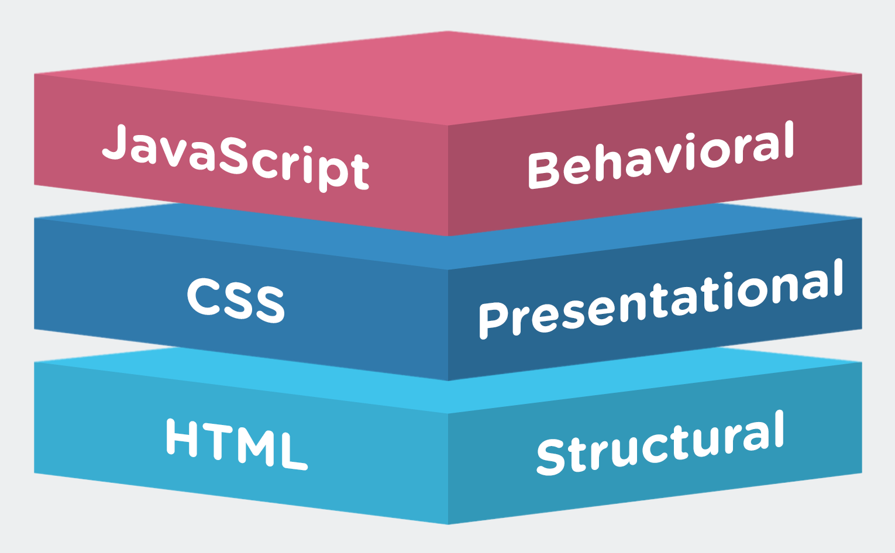Lesson 19 – JavaScript Basics

**JavaScript** is the programming language of HTML and the Web.

It is one of the 3 languages all web developers must learn:

1. **HTML** to define the content of web pages.

2. **CSS** to specify the layout of web pages.

3. **JavaScript** to program the behavior of web pages.

**JavaScript Introduction:**

* learn of what JavaScript (or **JS** for short) can do to **HTML** and **CSS**
* read the introduction at: <https://www.w3schools.com/js/js_intro.asp>

**How to insert JS to a webpage:**

* read and try: <https://www.w3schools.com/js/js_whereto.asp>
* discuss what are the advantages and disadvantages of:
  1. using the <script> tag inside a page <head>,
  2. using the <script> tag inside a page <body>,
  3. using an external .js file.

**How to print with JS:**

* read and try: <https://www.w3schools.com/js/js_output.asp>
* which way to print is the most useful to
  1. change the content of a page?
  2. send notifications to a user?
  3. debug a behavior of a webpage?

**Task:**

* Create a webpage that can draw various [TextArt](https://coolsymbol.com/text-art-pictures-images-ascii-characters-symbols.html) images by clicking different buttons.

Instructions:

1. First, create a new HTML file in Notepad++. Use the code from [this example](https://www.w3schools.com/js/tryit.asp?filename=tryjs_whereto_head) as a template.
2. Rename the **myFunction()** to **drawTextArt1()**, both in the definition and in the onclick attribute.
3. Change the displayed text of the button from **Try it** to **Draw Art 1**.
4. Select any of these [TextArt](https://coolsymbol.com/text-art-pictures-images-ascii-characters-symbols.html) images and copy it into the function, replacing the original text string. Use **backticks** **`** (instead of double quotes **"**) to properly create multiline strings and **<br>** to insert **newline** characters. The backtick key is located just below ESC on US/UK keyboards, or at ALT-Gr+7 on SLK keyboard. Example string is shown below:

document.getElementById("demo").innerHTML = `🡨 backtick here <br>

*__xxxxxxxxxxx______xxxxxxxxxx*<br>

*_xxxxxxxxxxxxxx___xxxxxxxxxxxxx*<br>

*xxxxxxxxxxxxxxxx_xxxxxxxxxxxxxx*<br>

*xxxxxxxxxxxxxxxxxxxxxxxxxxxxxxx*<br>

*_xxxxxxxxxxxxxxxxxxxxxxxxxxxxx*<br>

*__xx I LOVE JAVASCRIPT ! xx*<br>

*____xxxxxxxxxxxxxxxxxxxxxx*<br>

*_______xxxxxxxxxxxxxxxxx*<br>

*________xxxxxxxxxxxx*<br>

*__________xxxxxxxxx*<br>

*____________xxxxx*<br>

*_____________xxx*<br>

*_____________xx*<br>

*_____________\** backtick here 🡪`

1. Check the result by opening the page in a browser and clicking the button. In case of any errors or unresponsive scripts, press F12 in a browser to display a debugging console.
2. Add additional functions and buttons to rewrite the demo paragraph with other [TextArt](https://coolsymbol.com/text-art-pictures-images-ascii-characters-symbols.html) images :)